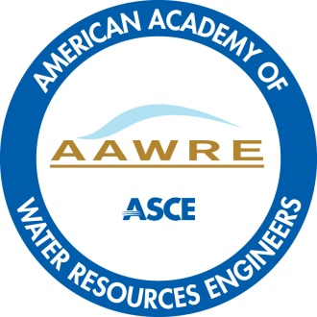

BOARD-CERTIFIED WATER RESOURCES ENGINEER APPLICATION
REFERENCE FORM

You have been listed by an applicant as a reference for the Board-Certified Water Resources Engineer board certification of the American Academy of Water Resources Engineers (AAWRE).

Please complete this entire form. You may type in the required information and save as your document. You may attach additional sheets to this form if needed.

Please email the form directly to the applicant.

Please note, no more than one reference may come from one organization, company or entity, if candidate has minimum of 3 professional references.

Applicant Name:

Reference Name: Date:

Reference Title:

Reference Business:

Reference Address:

Reference E-mail: __________

Signature (required on mailed copies):

1) If a Professional Engineer (P.E.) please list one U.S. state/jurisdiction in which you are licensed to practice engineering (or foreign equivalency):

State: License Number: Expiration Date:

2) How long have you known the applicant and in what capacity?

3) How would you compare the applicant in professional competence and promise with others you have known at this stage of their career? Please explain in at least 2-3 sentences but utilize as much space as you need to explain:

4) In what areas of water resources engineering do you consider the applicant to be an expert in (research, design, project management, etc.), please explain in at least 2-3 sentences but utilize as much space as you need to explain:

5) Can you give at least one example of a decision or situation where the applicant exercised exceptional professional judgment and/or behavior? Please explain in at least 2-3 sentences but utilize as much space as you need to explain:

6) Is the applicant of good moral character and of high ethical standing in the profession? Yes:______ No:_______

7) Do you recommend the applicant for board certification within water resources engineering as a Board-Certified Water Resources Engineer?

Yes: No:

